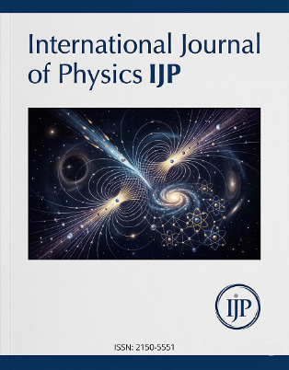
International Journal of Physics IJP
Publication Date: 30th August 2021
https://ijp-international-peer-reviewed-journal.iarrj.com/wp/

TYPE OR PASTE THE TITLE OF YOUR MANUSCRIPT HERE (NO MORE THAN 20 WORDS)
SURNAME Other Name(s)¹
Affliations, Department, University, City, Country.
Email: author@yahoo.com

SURNAME Other Name(s)²
Affliations, Department, University, City, Country.
Email: author@yahoo.com

ABSTRACT
The abstract should have up to 100–250 words in length (in MS Word highlight the section, Review/Word Count). Give a concise summary of the paper: research focus, research methods used, the results and the main conclusions and recommendations. Ensure that your abstract reads well and is grammatically correct. Use this document as a template if necessary or follow the instructions in Table 1 to compose your manuscript.

Keywords: Alternative Risk Transfer Solutions, Performance, Manufacturing Companies.

JEL Classification (Optional): must be provided. Choose JEL Classification Codes from the list http://www.aeaweb.org/jel/jel_class_system.php

Introduction
This document provides instructions for preparing manuscripts for publishing in International Journal of Physics IJP. The document is also a sample of layout for the manuscripts submitted for publication.
The open access to the papers is provided by IJP.
The manuscripts are accepted in English. Please use spell check. The submissions should be made electronically to the Editor-In-Chief at publication.ijp@iarrj.com. The Editorial team of the journal has the right to edit the submitted articles. If due to the request of the Editorial team, the author makes amendments to the manuscript, the Editorial team evaluates it anew.
In the introduction, context of the research should be established, the purpose and/or hypothesis that was investigated should be stated. Also, you can include the main idea, importance, novelty, etc. (use style Paragraph body).

1. GENERAL REGULATIONS
The organization of the body of the paper is at the authors’ discretion; the only required sections are Introduction, Methods and Procedures, Results, Discussion/Conclusion, and References. Acknowledgement section is encouraged but optional.
The recommended length of the manuscript is 8–20 pages including information about the authors, abstract and images (Article should not exceed 6000 words).
Introduction, Conclusion, References and Acknowledgment are not numbered. More requirements for a manuscript are provided in Table 1 and 2.
Proper citation of sources is necessary. The Journal uses the APA (name, date) reference system for citations in the text with a detailed alphabetical list at the end of the paper. Every reference cited in the text should be also present in the reference list and vice versa. For more details see section Reference style.

Table 1. Type Sizes, Spaces and Intervals (style Table title)
Name of style | Size (pts.) | Bold | Italic | Line spacing | Indent | Align-ment | Spacing  Before | Spacing After | Small/ All Caps
Paper title {Manuscript title} | 16 | + |  | single |  | Centered | 0 | 12 | All Caps
Authors names {Author names} | 10 | + |  | single |  | Centered | 0 | 12
Affiliation {Affiliation} | 9 |  | + | single |  | Centered | 0 | 0
Abstract, keywords {Abstract & Keywords} | 11 | + |  | single | Left and right 0.8 cm | Justified | 12 | 0
Section titles {Heading 1} | 11 | + |  | single |  | Centered | 18 | 12 | All Caps
Subheadings {Heading 2} | 11 | + |  | single | Hanging 1 cm | Left | 12 | 9
Main text {Paragraph body} | 11 |  |  | single | First line 0.7 cm | Justified | 0 | 0
Figure titles {Figure title} | 11 |  |  | single |  | Centered | 12 | 12
Text in figures  {Text in figures} | 10 |  |  | single |  |  | 0 | 0
Table titles {Table title} | 11 |  |  | single |  | Centered | 12 | 12
Text in tables {Text in tables} | 10 |  |  | single |  | Left | 2 | 2
Lists {Bulleted list}, {Numbered list} | 11 |  |  | single | Left 0.79 cm and hanging 0.63 cm | Justified | 2 | 0
Equations {Displayed equations} | 11 |  |  | single |  | Centered | 6 | 6
Acknowledgment {Acknowledgment} | 10 |  | + | single | First line 0.7 cm | Justified | 0 | 0
References {References} | 10 |  |  | single | Hanging 0.5 cm | Justified | 6 | 6
Authors’ short biography | 10 |  |  | single |  | Justified | 0 | 0

  - Page Layout (use style Heading 2)
If the list of template is deviated while working with it, follow these instructions:
- Click the Page Layout tab.
- In Page Setup section choose Size A4 (width 21 cm, height 29.7 cm).
- Insert Page Setup settings. Click margins, set: Top margin 4 cm, left margin 4 cm, right margin 3 cm, bottom 3 cm.
- Do not number the pages. Leave the header and footer blank.
  - Formatting lists and footnotes
For bulleted lists use an en-dash (–) rather than strong dot (•). It should be formatted in Times New Roman 12 pt, e.g.:
- First;
- Second;
- Third (use style Bulleted list).
To create numbered lists use the following style:
- First;
- Second (use style Numbered list).
Footnotes are most often used as an alternative to long explanatory notes that can be distracting to readers. It should be formatted in Times New Roman 10 pt (use style Notes).
  - Formulas and Equations
Formulas, equations and their components presented in the text must be written in Equation Editor (e.g. Microsoft Equation, Math Type). Select “Displayed equations” style for them. The size of basic symbols in equations should correspond to the letter size of the main text – 12 pt and formatted in Times New Roman. Place one or two tabs after the equations to put equation’s number flush with the right margin, as in (1). Number the equations consecutively with Arabic numbers.
All the numerals, including index numbers, are presented in Regular type, variables in Italic. Punctuate equations with commas or periods when they are a part of a sentence, as in
, (1)
where a is explanation, and b is explanation, etc. (all symbols must be explained).
If the lists are fewer than three items, the list is generally run in paragraph form, but if the lists are at least three items long, they are arranged as follows:
where
a explanation;
b explanation;
c explanation.
Please place equations in center. If the equation is longer, it should be split at appropriate algebraic symbols. The parts of the longer equations must be horizontally left aligned in the equation editor. The punctuation and numbers of longer equations, like (2), must be vertically centered with the last line of the equation.
${\left(x+a\right)}^{n}=\sum_{k=0}^{n}{\left({n \atop k}\right)x^{k}a^{n-k}}$ (2)
Use an en-dash (–) rather than a hyphen (-) for a minus sign. Reformatting of running text, into which special characters such as Greek letters have been entered via the keyboard, can cause these characters to disappear. In order to avoid this problem, always insert special characters to your document from Insert/ Symbol. In the Symbol dialog box select the required character and click Insert.
Use “(1)” not “Eq. (1)” or “equation (1),” except at the beginning of a sentence, for example, “Equation (1) is …”
  - Tables and Figures
All illustrations (line drawings and photographs) must be referred to in the text. Figures and tables should follow the requirements provided in Table 2. Do not use boldface for text within figures (diagrams, charts and schemes), for emphasis use Italic. All tables should be presented as a part of the text and should be editable (do not use any screenshots for figures and tables). Place figures and tables at the top or bottom of page. Avoid placing them in the middle.

- Tables
Tables are numbered consecutively with Roman numerals and have reference in the main text. Table captions and titles should be centered and placed above the table. Do not abbreviate the word “Table” in the caption.
Table 2. Requirements for tables and figures
 | Font | Line thickness | File formats
Tables | Times New Roman 10 pt 121010 p 10 pt | 0.5 pt | *.doc, *.docx
Photos and scanned images (resolution – no less than 300 dpi) | – | – | *.tif, *png, *.jpg
Diagrams, charts, schemes | Times New Roman 10 pt | From 0.3 pt to 2 pt | *.pdf, *.eps, *.cdr, *.xls, *.xlsx, *.dwg
Note: The width of figures and tables should not exceed the width of paragraph text.

- Figures
Number the figures consecutively with Arabic numerals. Figure captions should be placed below the figures and justified. One line figure captions may be centered. After title of figure obtain permission and include the acknowledgement required by the copyright holder if a figure is being reproduced from another source.

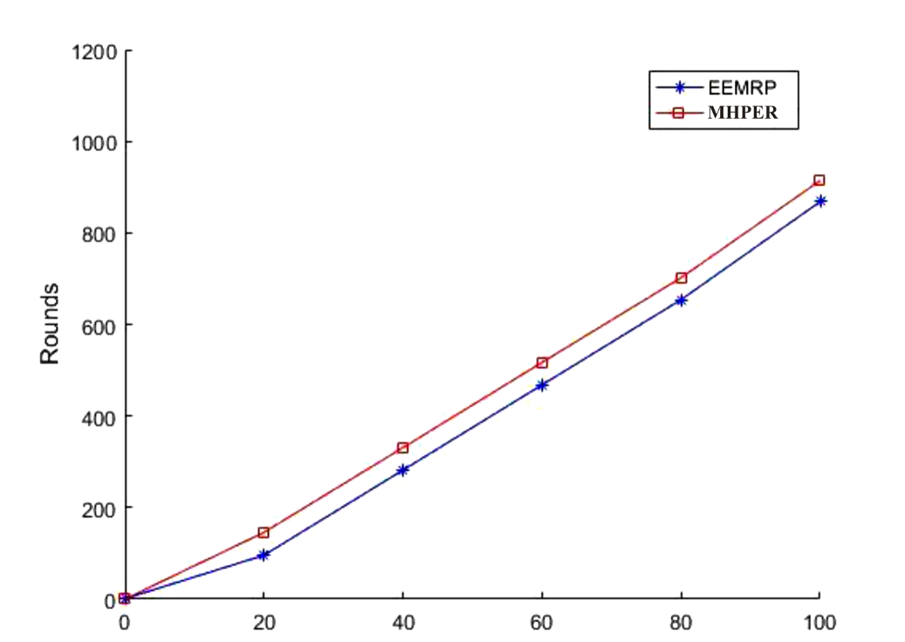
Throughput
Figure 1.1: Throughput Plot for 200m by 200m Network Field

Care and attention must be given to below guidelines because importing graphics packages can often be problematic:
- Figures in separate files should be saved in appropriate formats (see Table 2). The file name for the graphics should include their short description (e.g. Fig. 1, Fig. 2).
- In the printed volume, illustrations are generally black and white (halftones). If you use colored figures that are to be printed in black and white, please make sure that they really are also legible in black and white. Some colors show up very poorly when printed in black and white.

2. Reference Style
References at the end of this document are written according to the reference style APA style in the text with a detailed alphabetical list at the end of the paper. In the text number the citations consecutively in parentheses.
When quoting directly or indirectly from a source, the source must be acknowledged in the text by author name and year of publication. If quoting directly, a location reference such as page number(s) or paragraph number is also required.
When citing a section in a book, please give the relevant page numbers. In sentences, refer simply to the reference according to the APA style requirements. Do not numbering references. Do not use “Ref. (3)” or “reference (3)”.
If the title of the book you are referring to is, e.g., in Russian or Chinese, then please write (in Russian) or (in Chinese) at the end of the transcript or translation of the title. Word may try to automatically ‘underline’ hotlinks in your references; the correct style is NO underlining.
Where available please add DOI (Digital Object Identifier) to reference.
Please do not use automatic endnotes in Word, rather, update your reference list following the samples provided at the end of this document or use Mendeley reference management tool to automatically and easily cite source and create the reference list.

3. Submission checklist
The following list will be useful during the final checking of an article prior to the submission. Before sending the manuscript to the Journal for review, author/authors should ensure the following:
- The submission has not been previously published. Please note that all submissions will be checked to prevent plagiarism in published works.
- The text is prepared with a word processor and saved in .DOCX file (MS Office). If only older version of MS Office available then save in .DOC format.
- One author has been designated as the corresponding author.
- All authors should provide their e-mail addresses.
- The manuscript has been 'spell-checked' and 'grammar-checked'.
- References are in the correct APA reference format for this Journal. Please use MS Office reference generator or Mendeley tool.
- All references mentioned in the Reference list are cited in the text, and vice versa.
- Author/authors does/do not supply files that are too low in resolution. Authors should submit all images, schemes, diagrams as supplementary files through Open Journal System or in one .zip file.
- The submitted graphics are not disproportionately large for the content.
- Author agrees to submit signed and scanned Short Biography and Conflict of Interest Disclosure Form upon request before the manuscript is published. Author will also be asked to send the signed original of the agreement to the Editorial Board.

4. Additional information

4.1 Plagiarism
All papers submitted to International Journal of Physics IJP need to contain original work and must not be published in or submitted to other journals before the official notification deadline of International Journal of Physics IJP. In case the paper contains parts of previous work, these need to be referenced. All papers submitted to journal will be checked.

Conclusion
Conclusions or generalizations about your research should be presented using Times New Roman 11 pt (use style Paragraph).

Acknowledgment (Optional)
People who contributed to the work should be listed in the acknowledgments, along with their contributions. You must ensure that anyone named in the acknowledgments agrees to being named. Please avoid identifying any of the authors prior to peer review

REFERENCES
Auzina-Emsina, A., & Ozolina, V. (2013). Export, Industrial Productivity and International Competitiveness: A Case of Latvia. Economics and Business, 24, 14–20. https://doi.org/10.7250/eb.2013.002
Bloomberg, L. P. (2008). Return on capital for Hewlett Packard 12/31/90 to 09/30/08. Retrieved from Bloomberg database.
Central Statistics Office of the Republic of Botswana. (2008). Gross domestic product per capita 06/01/1994 to 06/01/2008 [statistics]. Retrieved from CEIC Data database.
Colvin, G. (2008, July 21). Information worth billions. Fortune, 158(2), 73–79. Retrieved from Business Source Complete, http://search.ebscohost.com
Commission on Growth and Development. (2008). The Growth Report: Strategies for Sustained Growth and Inclusive Development, World Bank. Retrieved from http://www.ycsg.yale.edu/center/forms/growthReport.pdf
Deming, D., & Dynarski, S. (2008). The lengthening of childhood (NBER Working Paper 14124). Cambridge, MA: National Bureau of Economic Research. https://doi.org/10.3386/w14124
Dlouha, J., Barton, A., Huisingh, D. & Adomssent, M. (2013). Learning for Sustainable Development in Regional Networks, Journal of Cleaner Production, 49, 1–4. https://doi.org/10.1016/j.jclepro.2013.01.041
Homburg, C., Artz, M., & Wieseke, J. (2012). Marketing Performance Measurement Systems: Does Comprehensiveness Really Improve Performance? Journal Of Marketing, 76(3), 56–77. https://doi.org/10.1509/jm.09.0487
Frank, R. H., & Bernanke, B. (2007). Principles of macro-economic (3rd ed.). Boston: McGraw-Hill/Irwin.
Jones, C.I. (2010). Macroeconomics. Economics Crisis Update. New York, London, MA: W.W. Norton&Company.
Jones, P., Trier, C. J., & Richards, J. P. (2008). Embedding Education for Sustainable Development in higher education: A case study examining common challenges and opportunities for undergraduate programmes. International Journal of Educational Research, 47(6), 341–350. https://doi.org/10.1016/j.ijer.2008.11.001
Latvia’s government. New currency, new leader. (2014, Jan. 11). The Economist, p. 35.
Mygind, N. (1999). Privatization, Governance and Restructuring of Enterprises in the Baltics. OECD. Retrieved July 21, 2017, from http://www.oecd.org/corporate/ca/corporategovernanceprinciples/1931548.pdf
Rosen, C., Case, J., & Staubus, M. (2005). Equity: Why Employee Ownership is Good for Business, 32–34, Boston: Harvard Business School Press.
Sinevciene, L. (2013). The Impact of Government’s Fiscal Policy on Private Investment (Doctoral dissertation, Kaunas University of Technology).

Footnotes should be formatted in Times New Roman 10 pt (use style Notes).

